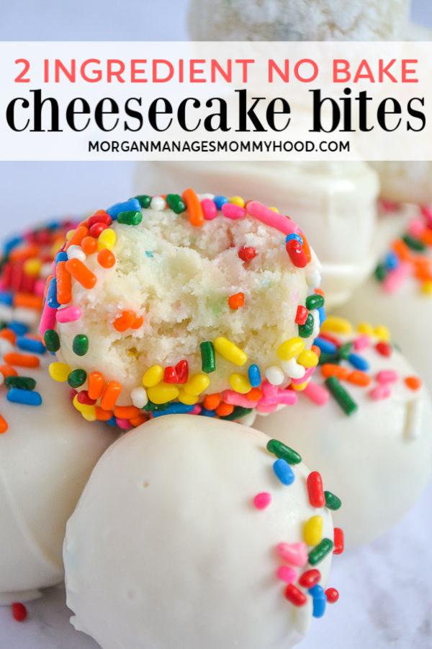
2 Ingredient No Bake Cheesecake Bites
Ingredients:
- 1 Box of cake mix
- 18 Oz of cream cheese softened
- Sprinkles, white chocolate (optional)

Method:
- Cream the cream cheese until light and fluffy with a hand or stand mixer.
- Add in the cake mix until completely combined, and allow to sit for about 1 hour.
- Roll into balls about 1 tablespoon in size and enjoy.
- If desired, roll your balls in powdered sugar, sprinkles, or extra cake mix. You can also dip them in melted white chocolate and top with sprinkles.

Ice Cream Cone Cupcakes

Ingredients:
- Small Ice cream cones
- 1 cake / cupcake mix
- Butter & icing sugar
- Sprinkles
- Cherries

Method:
- Start by making your cake mix according to the box instructions. Place the ice cream cones into a muffin tin – one cone in each spot, if you do not have a cake mix at home you can always look up a basic cupcake/ cake recipe and use it instead
- Fill the cone about ¾ of the way full of cake batter
- Bake in oven at 200 degrees for 25 mins
- When cooled down, add on the icing which is mixing the butter and icing sugar together in a bowl until smooth and add to top of cupcake
- Add the sprinkles and a cherry on top & enjoy

Funfetti Baked Donuts
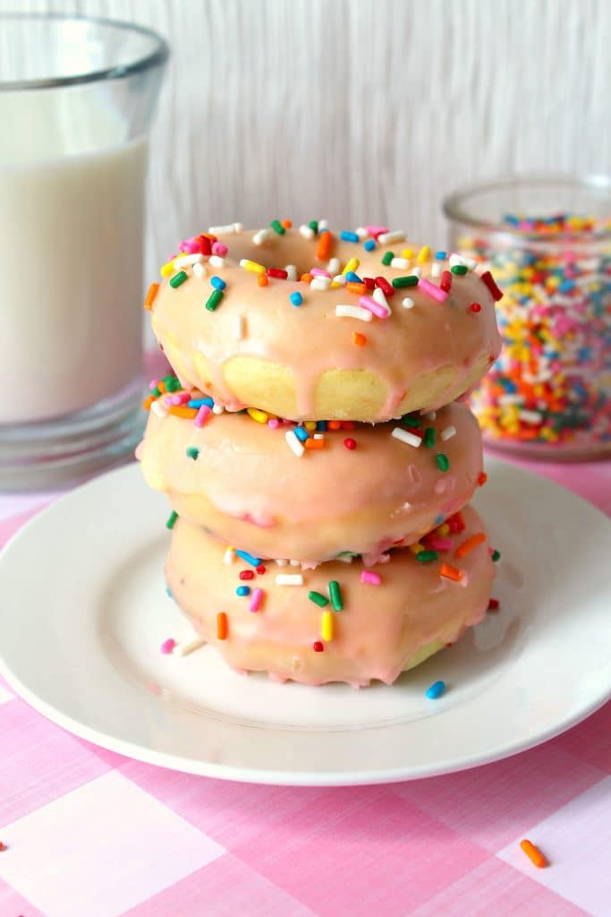
Ingredients:
- 2 eggs
- 4 Tbsp. butter, melted
- 1 tsp. vanilla extract
- 2/3 cup sugar
- 2 cups flour
- 1/2 tsp. salt
- 1 1/2 tsp. baking powder
- 1 cup skim milk
- 1/4 cup rainbow sprinkles
- Donut shaped pan tray
For Glaze
- 2 cups powdered sugar
- 1 tsp. vanilla
- 4 Tbsp. milk
- Food coloring for your glaze
- Rainbow sprinkles for topping

Method:
- Preheat oven to 350º. Spray 2 donut pans with cooking spray. These are my favourite donut pans.
- Using a mixer, beat the eggs in a mixing bowl until blended. Add butter, vanilla and sugar and mix until smooth.
- Add to your egg mixture, flour, salt and baking powder , combine until all ingredients are fully mixed. Add milk and stir until smooth. Add rainbow sprinkles.
- Add batter to prepared donut pans
- Bake for 12 -15 MINS, then let them cool
- When they are cooling , mix up the glaze by combining powdered sugar, vanilla, and milk together and mix until smooth
- When donuts are fully cooled add the glaze & enjoy

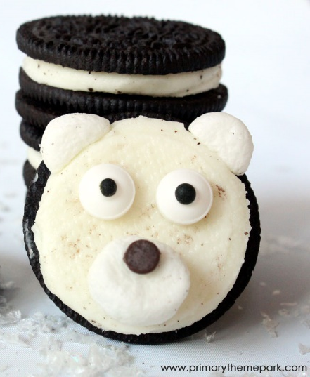
Polar Bear Cookies
Ingredients:
- cream filled cookies (Mega Stuffed or Double Stuffed Oreos work best)
- mini marshmallows
- mini chocolate chips
- edible candy eyes

Method:
- Carefully twist the cookies apart to separate the top and the bottom. Keep the part of the cookie with the cream. Eat the part without the cream
- Take a mini marshmallow and press it between your finger and thumb to flatten it and place it on the centre of the bottom apart of the cream
- Press the pointed end of a mini chocolate chip piece into the top centre of the marshmallow for the nose.
- place the edible candy eyes on the cream and gently press into place.
- Cut one mini marshmallow into fourths with kitchen scissors. Use two of the fourths on top of the cream for the ears. The marshmallows are a bit sticky once you cut them so they hold nicely when stuck to the cookie & enjoy

