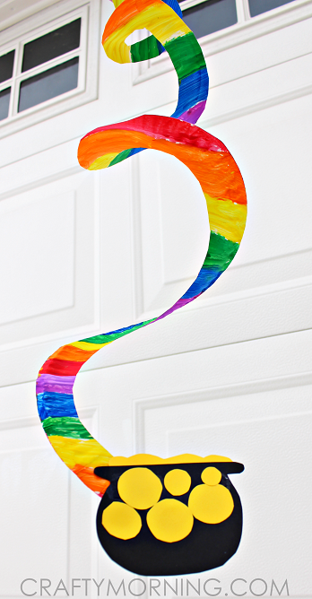
March Arts Idea’s Junior
End of the Rainbow Paper Twirler

Equipment:
- Paper Plate
- Paint
- Black and yellow paper
- Scissors
- Glue
Method:
- Start by painting rainbow pattern strips on the front of the paper plate, then let it dry and flip it over to paint the back as well.
- Grab your scissors and start at the outside of the plate to cut spirals, cut out a black pot of gold and glue it to the end of the plate
- Glue on some yellow circles to make the golf, you can add some sparkles too, poke a hole in the middle of the plate and add a string to hang it up

3D Over the Rainbow Craft
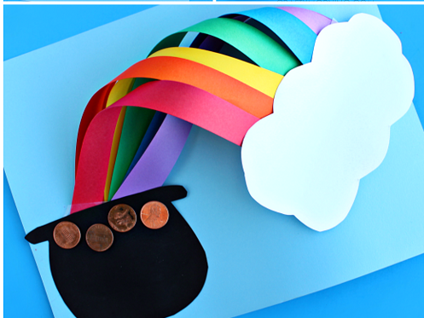
Equipment:
- Red, orange, yellow, green, blue, purple, white and black paper
- Scissors
- Tape
- Coins/ glitters

Method:
- Start by cutting long strips of paper, lay them in order of the rainbow colours and tape them at the bottom slanted, cut out a pot of gold with black paper and glue it to the end of the strips
- Take two papers strips at a time, make a loop and tape it to the paper
- Once all the rainbows strips are done, roll pieces of tape and attach a fluffy white cloud at the end of the rainbow
- Add some glitter/coins to resemble gold

3D Rainbow Fine Motor
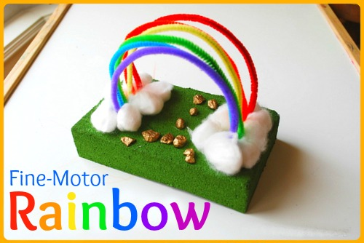
Equipment:
- Coloured pipe cleaners
- Cotton balls
- Glue
- A block of green florist foam/ OR you can you use a green wash sponge
- Gold objects (gold painted stones)
Method:
- With a marker, mark 6 dots in a line on each side of the foam. Stick the ends of the pipe cleaner into either end of the foam to make an arch shape
- Squeeze the glue around the bottom of the rainbow and stick the cotton balls
- Find some gold small objects to place at the bottom of the rainbow and glue down with glue

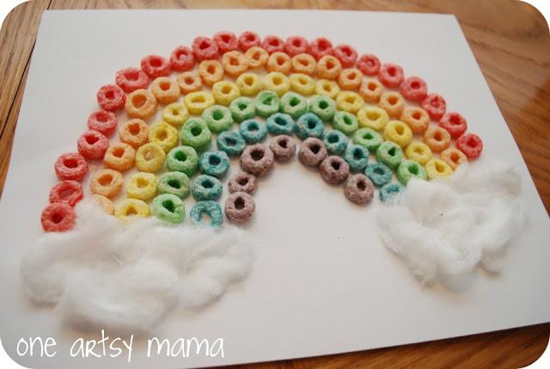
Loopy Rainbow
Equipment:
-Fruit loops / painted cheerio’s
-Glue
-Cotton wool
-any coloured paper

Method:
- Sort out the colours of the rainbow and with each colour make an arch under each other as seen in the picture
- Glue each fruit loop down with glue until you get a rainbow
- Glue down some white cotton wool to each end of the rainbow

Clover Leaf Craft
Equipment needed:
- String/ wool
- Coloured/ designed paper
- Scissors
- Cut up straws Hole punch

Method:
- Cut out some clover leaves in loads of different colours and designs
- Punch a hole in the centre of each clover leaf but a little smaller than the width of your straws as you don’t want the straws to get through
- Next cut a length of string that you want as your necklace and then start to string through the clover leaves and the straws
- After each clover leaf you should add a straw piece, once the necklace is full tie a knot with the two ends
- Now you a necklace!!

