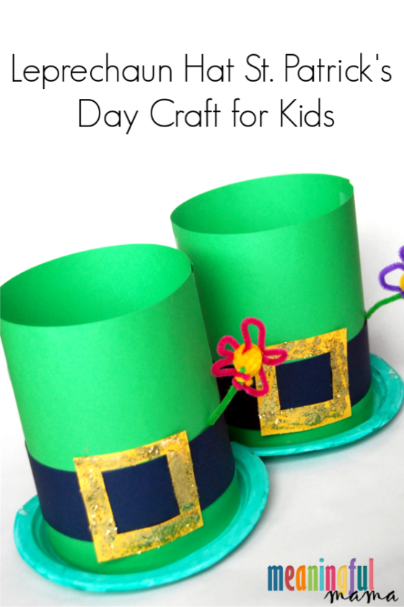
Equipment:
1:

- Paper plates
- Stock/ card paper (green, black, yellow)
- Gold glitter
- Pipe cleaners
- Green craft paint / colouring pencils
- Tape
- Sponge
- Scissors
- Glue
Method:
- Take the paper plate and cut out the centre, then paint/ colour with paint or colouring pencils green.
- Take 2 pieces of green stock/card paper and stick together using tape to form a cylinder shape.
- Next take the yellow-coloured paper and cut out a square any size but big enough for the hat, when you have the square shaped piece cut another smaller square shape inside the larger square.
- Cut two 2.5’width of black paper, using double sided tape (or normal tape folded) you can stick on the black around the hat
- With the yellow buckle we just made, stick this on top of the black trim on the hat using tape also
- You can decorate the buckle with glitter this is optional

Leprechaun lookers
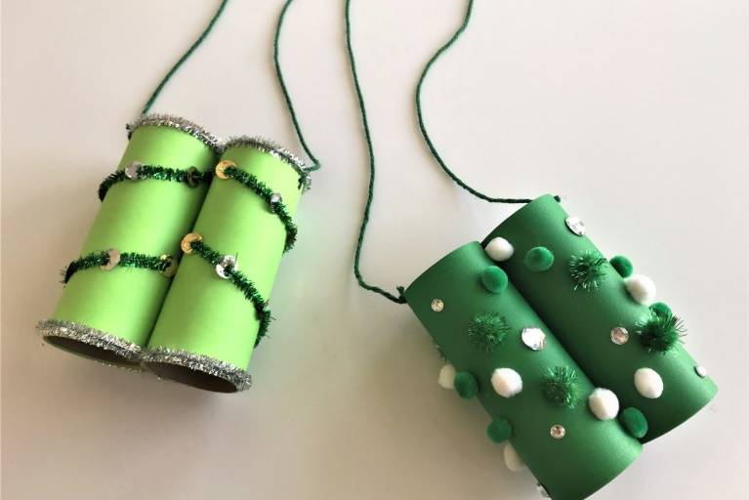
equipment:
- 2 toilet paper rolls
- Paper
- Glue
- Scissors
- Decorations: pipe cleaner, pom-poms, glitter (up to you)
- String
Method:
- Measure your paper and cut it to the length of the paper toilet rolls
- Glue your paper onto your rolls, glue the first part of your paper onto the roll and then wrap it all the way around the glue
- Glue the 2 toilet rolls together side by side (if you use pipe cleaner to decorate you may have to wait for it to dry before gluing the two rolls together
- Add your decorations
- Punch a hole at the top of each roll on the outside part using a hole puncher or scissors
- Tie your string to each hole of the rolls and you’re done!!

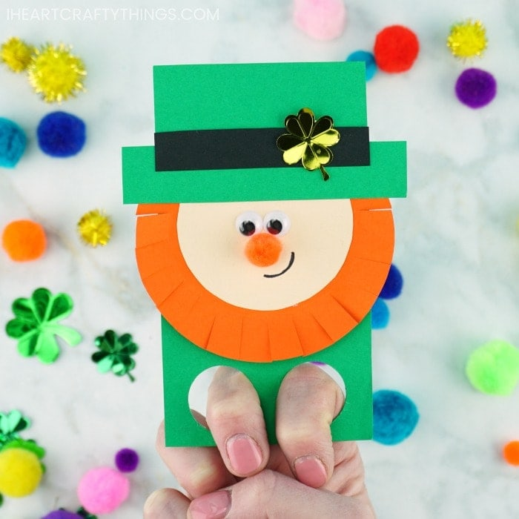
LEPRECHAUN FINGER PUPPETS
Equipment:
- White card paper
- Pencil
- Green, orange, cream, black paper (if you don’t have coloured paper you can always colour is white paper with colouring pencils)
- ¾ inch circle punch
- Small googly eyes
- Orange pom pom
- Glue stick
- Scissors
Method:
- Start off by getting your green paper and cutting rectangle shape 10 cm in length by 5 cm in width
- At the bottom of this rectangle punch two holes large enough to fit 2 of your fingers through.
- With your orange paper cut a semi-circle with the diameter of 7cm across and cut a smaller semi-circle with your cream paper
- With your orange paper with your scissors cut small incisions around the edge
- With glue stick on the orange paper first followed by the cream on top
- Cut out a rectangle shaped length 7cm and width 2cm with your green paper and another rectangle 5cm in length and 3cm in width
- Glue on top of each other like the picture above and then glue on top of the orange and cream paper
- Stick on your googly eyes and draw with marker a smile for your leprechaun

