2nd March 2020
Dear Parents,
There will be Girls Football Training after school today Monday, in Robertstown GAA pitch from 2.45-3.30pm.
Please keep bringing in tin/cans for our Junior Entrepreneur Programme. Thanks in advance, 5th class.
Athletics Club is starting next Thursday 12th of March from 2.35pm-3.15pm, it will be held out in school yard for pupils from 3rd-6th class, meet at Ms Cullagh’s room. Thanks from Ms. Poole and Ms. Cullagh.
World Book Day is this Thursday 5th of March. Children if they wish can dress up as their favourite character. Book tokens were given out to children today. Any books in good condition that are not needed anymore can be donated to the school library. Thank you to all who have sent in books over the past few months. Much appreciated!
Senior Boys Football training from 4th-6th classes will start next Monday 9th of March after school in Robertstown GAA from 2.45-3.30pm.
Thank you to all who left in bags of clothing into the school, a total of €160.00 was raised for the school by the collection.
Robertstown National School will be closed on Monday 16th and Tuesday 17th of March, due to St. Patricks weekend.

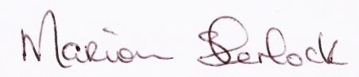
Marion Sherlock

