March 2020
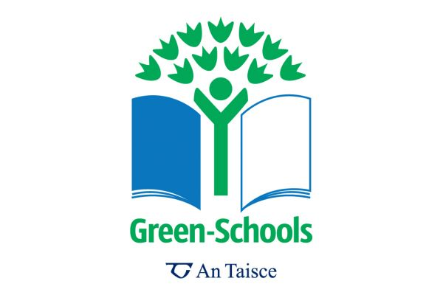

Dear Parents/Guardians
The RNS Green Schools committee would like to keep you updated on our progress so far this year, as well as keeping you informed on some new initiatives.
We have recently applied for our 6th green schools flag – Global Citizenship, Litter and Waste. We are hoping to hear news on this soon so keep your fingers crossed for us!
Supervalu are running a ‘Save the Bees’ campaign and have supplied us with some learning materials as well as wild flower seeds which we are going to plant at the back of the school. They have also invited us to take part in their school cards collection programme, if we fill the board with their cards we could be in with a chance of winning up to €50,000 for the school. So if you are shopping in SuperValu please ask for a card/cards at the till and send them into school with your child.
Finally, we were recently shown some ‘Beekeeperz’ which are 100% Biodegradable and eco-friendly food wraps, allowing you to avoid the use of tinfoil and cling film. They are made by Louise who is a parent in the school. They can be washed and re-used so it’s very economical too! We think they are a brilliant idea and would encourage you all to take a look at Louise’s facebook page (@BuzyLouize), or alternatively email louisevignes@gmail.com, for more information.
We really appreciate your help in our green schools efforts and we hope to be letting you all know that we have received our 6th green schools flag very soon!

Thank you,

The Green Schools Committee

