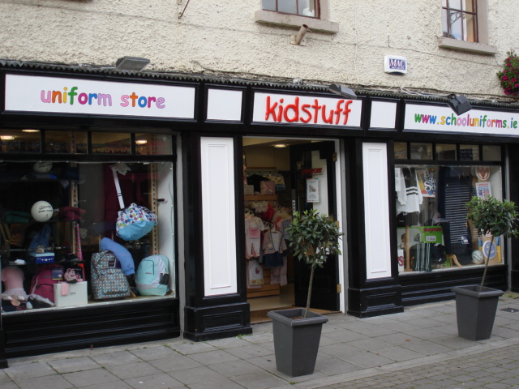

PRICE LIST
Track suit bottom €18.50
Track suit top €19.50
Jumper €21.99
Jumper (sizes 36 upwards) €25.99
Cardigan €25.99
Cardigan (sizes 36 upwards) €28.99
Our prices are based on the cost of the goods, plus we are a retail store offering a fitting service, various payment options and we carry stock in all sizes 12 months of the year.
We are happy to offer a discount of 10% on all goods paid for in full, from today until month end.
We are now offering a full and secure online ordering service. If however you would prefer not to order online we would be delighted to process your order or query in any of the following ways:
1. Call us directly Tel: Mon - Sat (10:00am - 5:00pm) on +353 (0)45 486445 or fax on +353 (0)45 449347
2. Email us at info@schooluniforms.ie
3. Send your written order with a cheque or postal order to us at:
Kidstuff, 31 Georges Street, Newbridge, County Kildare, Ireland
From first contact to completion, an assistant will be designated to deal with your query or order. Your personal assistant will respond within 3 days.
Payment
We will accept payment in any of the following ways -
Cash - paid directly into shop
Cheque - can be posted or given into shop (made payable to Kidstuff)
Credit Card - over telephone or in shop

